Hoa Loi Primary School
Student’s name: …………………………….. ; Class: 3…..

ĐỀ ÔN TIẾNG ANH LỚP 3 ĐỀ 1 ( TỪ 30/3 – 3/4/2020 )

1 Look and write.


4

1 hands

5

2

3 6

2 Complete the sentences.
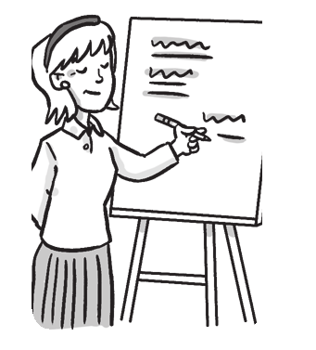

1 2

She’s a teacher. a doctor.

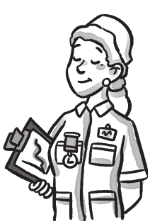
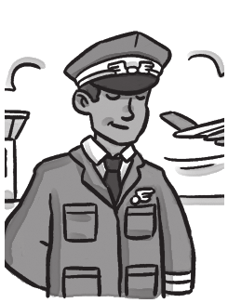
3 4

a pilot. a nurse.

3 Read and answer the questions. Circle A, B, or C.

I’m Nam. This is my house. I can see the park from my window. I can see a slide and a goal in the park. My friend, Vinh, is in the park. He is on the slide. Vinh has a dog. It is under the slide. There’s a pool in the park, too. I can see a boy in the pool. He is my brother. I like playing in the park!

Example What is the boy’s name?

(A) nam

(B) Nam

(C) Vinh

1 What can Nam see?

(A) He can see a slide, a pool and a goal.

(B) He can see a girl, a pool and a slide.

(C) He can see a pool, a boy and a cat.

2 Where is Vinh?

(A) He is under the slide.

(B) He is in the pool.

(C) He is on the slide.

3 Where is Nam’s brother?

(A) He’s in the house.

(B) He’s in the pool.

(C) He’s in the goal.

