Hoa Loi Primary School
Student’s name: …………………………….. ; Class: 5…..
ĐỀ ÔN TIẾNG ANH LỚP 5 ĐỀ 2 ( TỪ 30/3 – 3/4/2020 )

1.Look at the table. Are the sentences true or false? Write T or F , then write sentences.

 | Ben | Lily | Toby | Anna
get up early
go to school by car
play tennis
get dressed at 8 o’clock

- Ben gets up early. | T | He gets up early.
- Lily goes to school by car.
- Toby doesn’t play tennis.
- Anna gets dressed at 8 o’clock.
- Ben goes to school by car.
- Lily plays tennis.
- Toby gets up early.
- Anna goes to school by car.

2.Look and answer the questions.

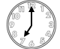 |  | 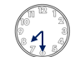
What time does he get up ? | What time does he have breakfast? | What time does he brush his teeth ?
He gets up at seven o’clock.. | ………………………………………. | ……………………………………
 | 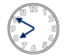 | 
What time does he have a shower ? | What time does he comb his hair ? | What time does he get dressed ?
………………………………………. | ………………………………………. | ……………………………………
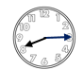 | 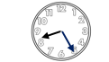 | 
What time does he prepare his bag ? | What time does he put on his coat ? | What time does he go to school ?
………………………………………. | ………………………………………. | ……………………………………

