Hoa Loi Primary School  Class: ………………  Name:……………………………………….. | Review 6

ĐỀ ÔN TIẾNG ANH LỚP 4 ( ĐỀ 2 TỪ 16 – 20/3/2020 )

- Look and read. Write yes or no. There are two examples.

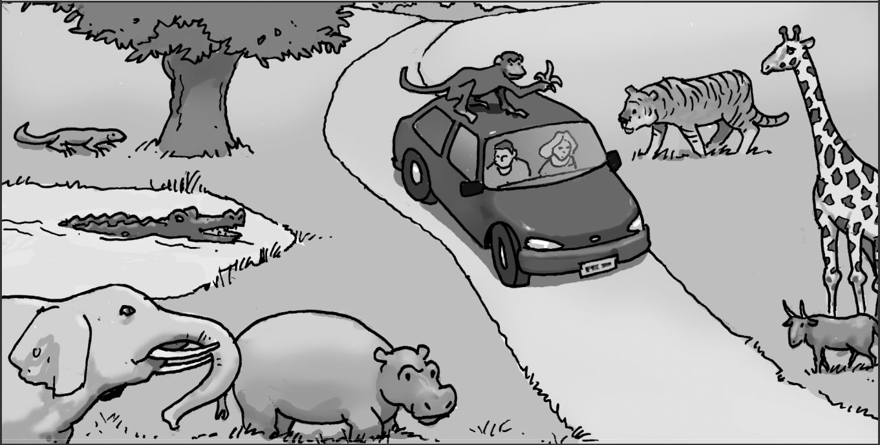

Examples

There is a crocodile in the water. ------YES--------

The monkey is next to the car. ------NO----------

Questions

- The tiger is between the giraffe and the goat. -------------------------

- There are two people in the car. -----------------------

- There is a snake under the tree. -----------------------

- The monkey has got a banana in its hand. ----------------------

- The goat is in front of the giraffe. -----------------------

- Look and write.
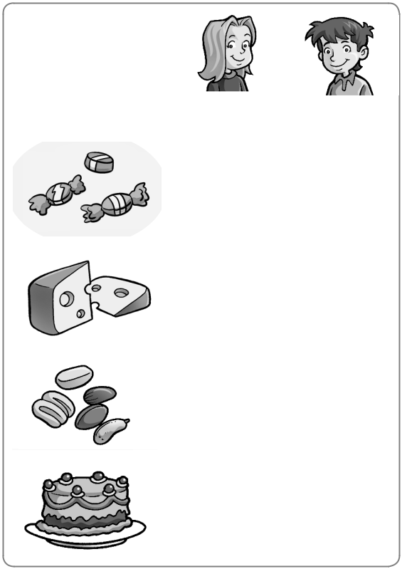

 |  |  | 1 | Celia |  |  |  | likes candy.
 | Celia | Max | 2 | She |  |  | doesn’t like |  |  |  | cheese.
 | 3 | 3 | 3 | She |  |  |  |  |  | nuts.
 |  |  | 4
 | 7 | 3 | 4
 | 7 | 3 | 5 | Max |  |  |  |  |  |  |  |  | candy.
 |  |  | 6 | He |  |  |  |  |  |  |  | cheese.
 | 3 | 7 | 6 | He
 | 3 | 7 | 7 | He |  |  | .
 | 3 | 3 | 7
 | 3 | 3 | 8

- Underline the correct word.

- What ( do / does / doesn’t) you like?

- What does (I / they / he) like?

- He (like / likes / don’t like) candy.

- What (do / does / don’t) she like?

- She (don’t / hasn’t / doesn’t) like nuts.

- Circle the odd-one-out. Write.

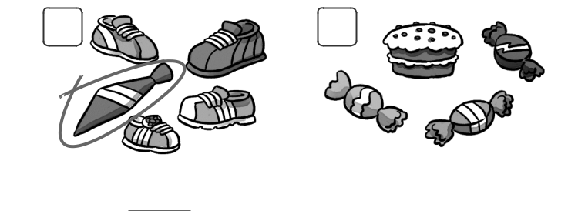
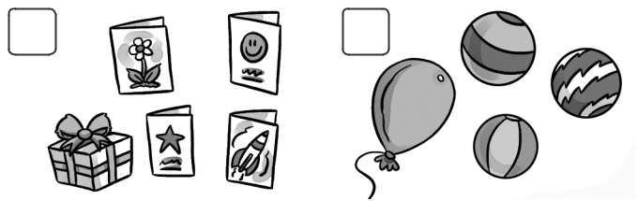
1 2 3 4

Tie _____________ _________ _____________

