Hoa Loi Primary School
Student’s name:……………………….
Class : …………
DE CUONG ON TAP MON TIENG ANH KHOI 2 ( Đề 1 )
I.Write ( viết ) 2m
mommy, swing, daddy, soup, run, slide
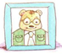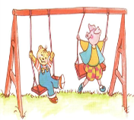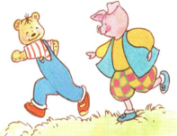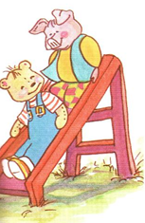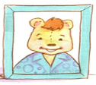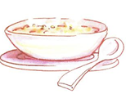
_______ ________ ________ ________ ______ _______
II. Check (đánh dấu vào ô đúng)
1.  sky 5. 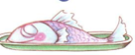 bread 9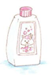towel
moon fish shampoo
2.  meat 6.  soup 10.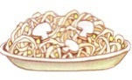 noodles
noodles rice soup
3 sky 7.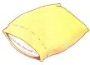 pillow 11.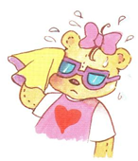 I’m wet
stars towel I’m hot
4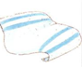towel 8. bear 12.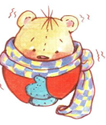 I’m cold
pillow blanket I’m wet
III. Complete the conversation (hoàn tất bài hội thoại sau)
1.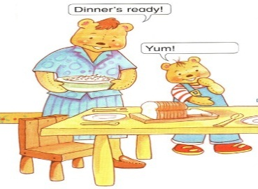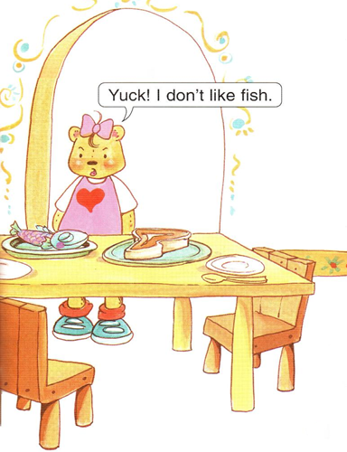
A.Yum ! I like fish
B. Yum ! I like meat
C. Yum ! I like bread
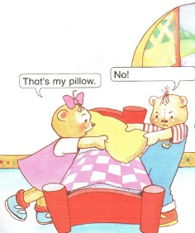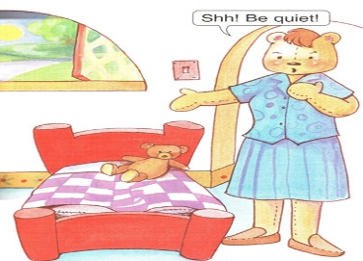
2. A.It’s my bear
B.It’s my blanket
C.It’s my pillow
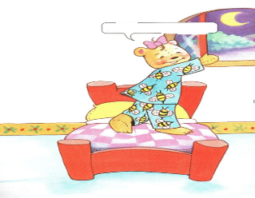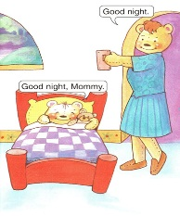
3.A.Look at the sky
B.Look at the stars
C.Look at the moon
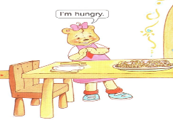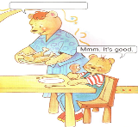
4. A.Have some noodles
B.Have some chicken
C.Have some soup
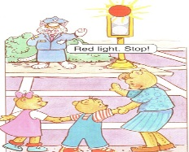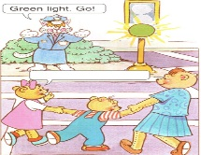
IV Match ( nối các câu sau )
1. police officer 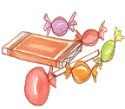
2.ice-cream 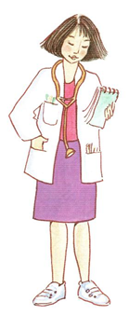
3. doctor 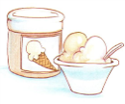
4.candy 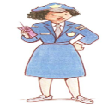
5. bear 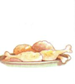
6. chicken 