Hoa Loi Primary school
Class:…………………..
Name:………………………………….

ĐỀ ÔN TIẾNG ANH LỚP 4 ( ĐỀ 2 )
- Circle the odd-one-out. Write.

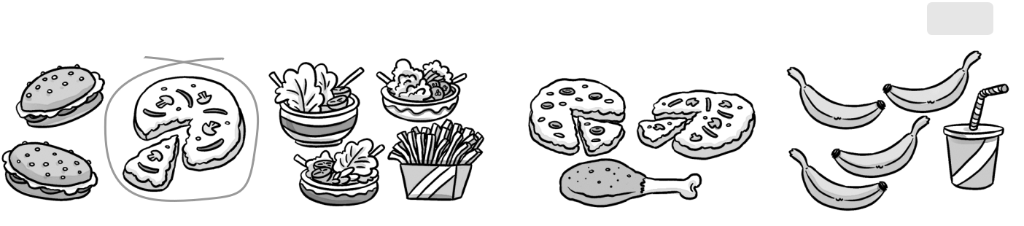

1 | pizza |  | 2 | 3 | 4
 | II. Match.
 | 1 |  | 2 3 | 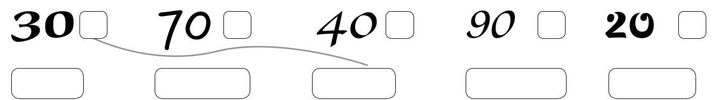 | 4 | 5
 | 1 | c
 | a. forty |  | b. twenty | c. thirty | d. seventy | e. ninety
III. Underline the correct words.
 | 1 |  | 2 |  | 3

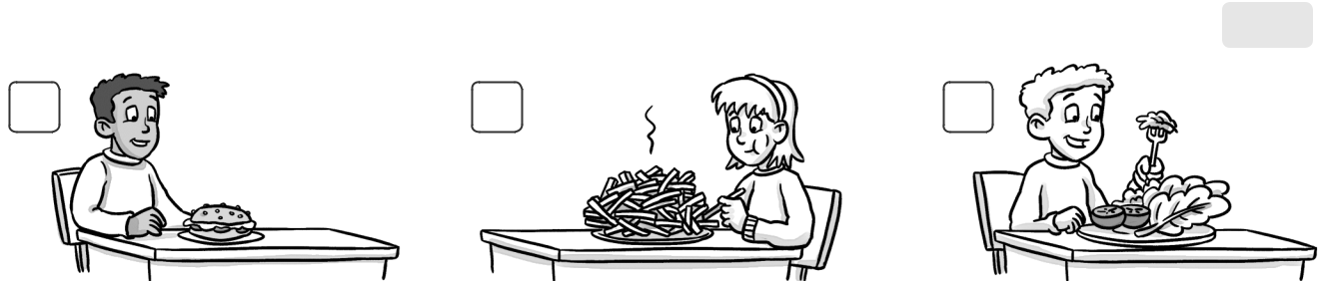

- (Does / Do / Is) you have a pizza?

- (Are / Does / Do) she have fries?

- (Is / Does / Do) you have salad?

No, I (doesn’t / Yes, she (does / Yes, I (do / does /

don’t / do). doesn’t / do). don’t).

IV. Circle the correct word.

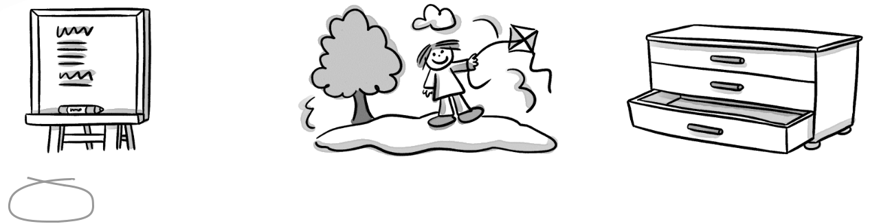

1 board / poster | 2 picture / computer | 3 drawers / table

V. Complete. | Do | doesn’t have Yes | 3 Does Erica
 |  |  | a mikshake?
1 Do you
have a
sandwich?
 | 2 | , I do. | 4 No, she | .
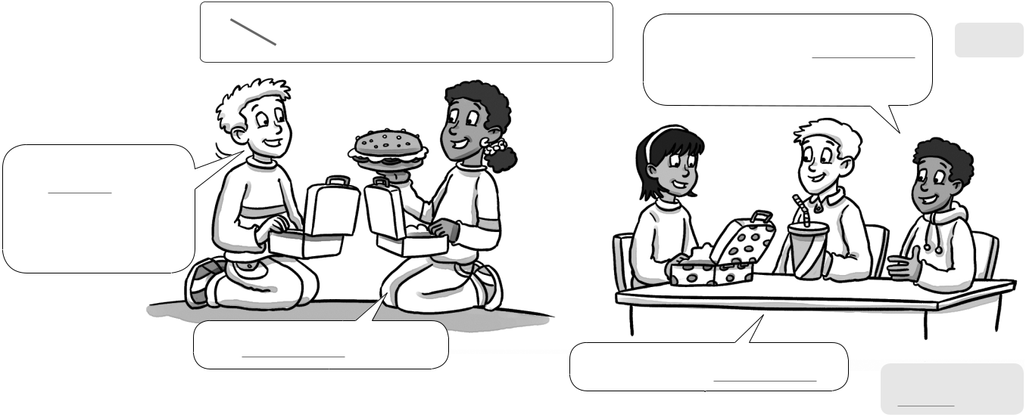

VI. Read. Circle the correct answer.
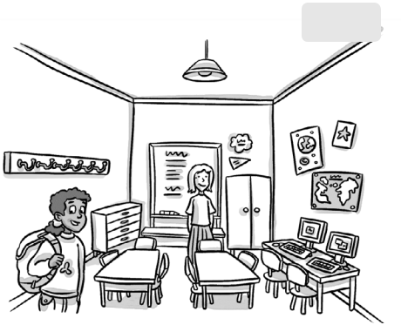

/3

Hello! My name’s Daisy. I’m eight. This is my classroom. There are three tables and eight chairs. That is my teacher, Miss Green. She is in front of the board. There are two computers in my classroom. There are pictures on the wall. There are lots of coat hooks. My coat hook is blue. This is my bag, it’s yellow.


- How many tables are there?

- How many chairs are there?

- How many computers are there?

- What color is Daisy’s coat hook?

three / four

nine / eight

three / two

blue / yellow

Read again and write T (true) or F (false).
1 | Daisy is nine. F | 2 Miss Green is Daisy’s teacher.
3 | There are pictures on the wall. | 4 There are three computers.
5 | Daisy’s bag is blue.

