Hoa Loi Primary School
Student’s name:…………………………….
Class: ……………
ĐỀ ÔN TIẾNG ANH LỚP 5

1.Look and correct the sentences.
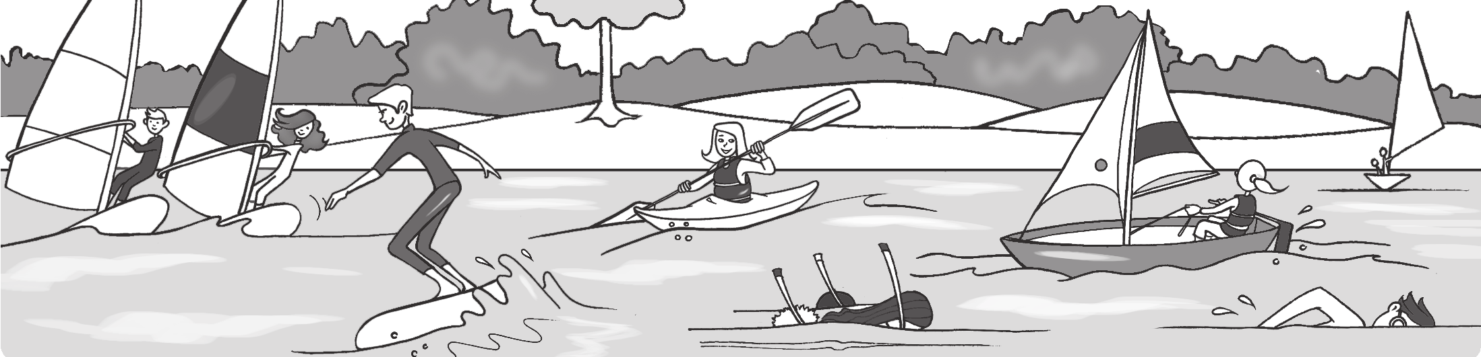

2 4 5
1

3 6

1 They’re kayaking. They aren’t kayaking. They’re windsurfing.

2 He’s swimming.

3 They’re sailing.

4 She’s snorkeling.

5 She’s waterskiing.

6 He’s surfing.
2.Circle the correct phrase.
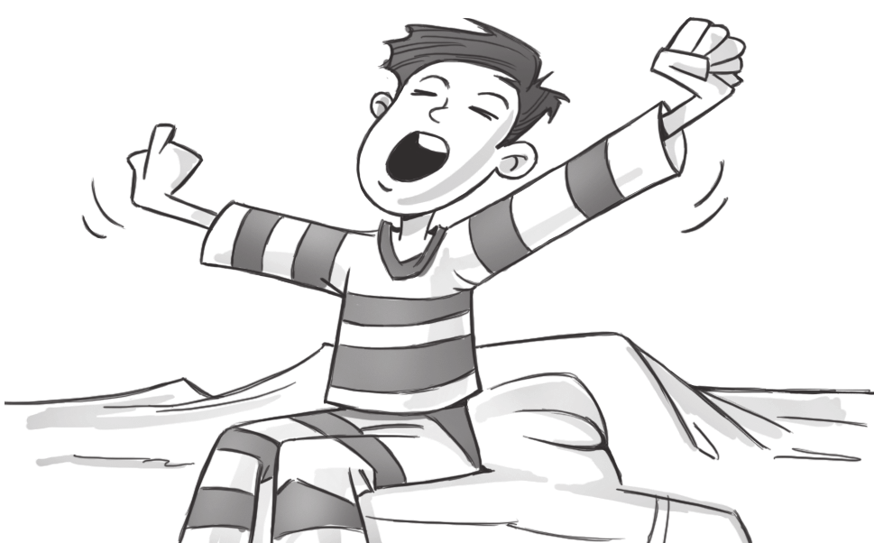
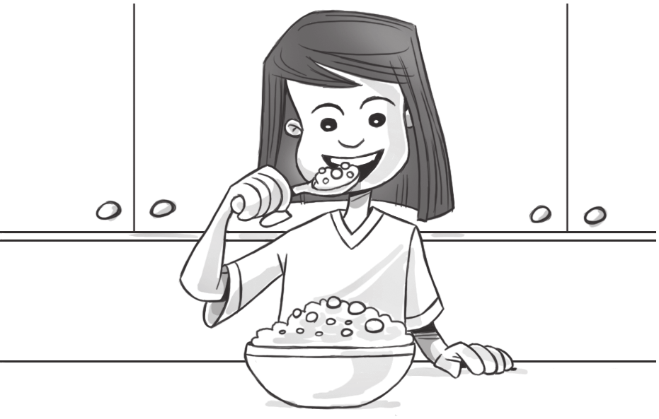

1 2

have breakfast/ get dressed get up / brush my teeth
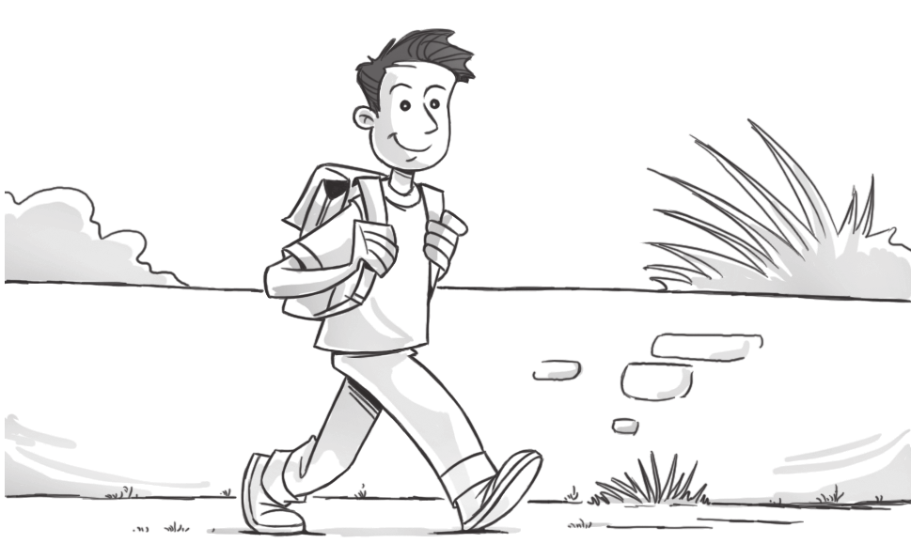
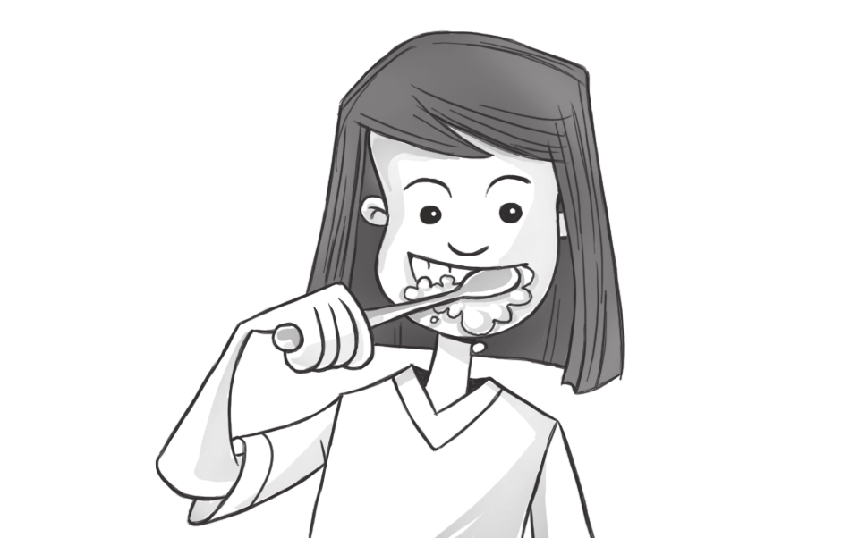
3 4

have a shower / brush my teeth catch the bus / walk to school

3. Complete. every day First every day Finally Next

I get up at seven o’clock 1 every day . 2 , I have a shower. Then I get dressed. 3 , I brush my hair and have breakfast. 4 , I brush my teeth. Then I go to school. But I don’t go to school 5 .

4. Underline the correct words
Tim What time 1 do you / does you / you do get up on Saturdays?
Carl I 2 get up / gets up / getting up at eight o’clock. But my brother Simon 3 get up / getting up / gets up at nine o’clock. He’s very lazy.
Tim 4 Doing / Does / Do your friends go to the park on Saturdays?
Carl Yes, they 5 don’t / do / does. We 6 plays / playing / play soccer there. But my sister 7 doesn’t / do / don’t come.
Tim What 8 do / does / don’t she do?
Carl My mom and my sister 9 does / do / don’t the food shopping
together on Saturdays.

5.Write the words.



1 2 3 4 5







cow

