Hoa Loi Primary School
Student’s name:…………………………………………
Class: ……..
ĐỀ ÔN TIẾNG ANH LỚP 3
1. Write and match.
1. i k e t kite

2. o l d l ____

3. n t r i a _____

4. d t e d y r a e b ______

5. i k e b ______

2. Order the words.

a. This / bike. / is / my
- This is my bike.
b. it / Yes, / is.
- …………………………………………….
c. my / This / kite. / Is
- ………………………………………….
d. your / Is / this / train?
- ………………………………………………………..
e. isn’t. / it / No,
- ……………………………………………………….
f. this / your / bag? / Is
- …………………………………………..

3. Complete the answers.

1.Is this your teddy bear? Yes, it is .
2. Is this your doll? No, it .
3. Is this your hat? No, .
4.Is this your train? Yes, .

4.Look and write: Yes, it is. No, it isn’t.

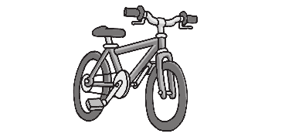

1. Is this your bike ? Yes, it is.


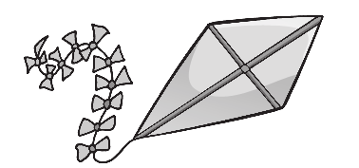
2. Is this you ?


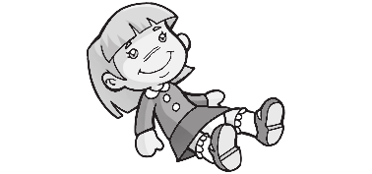
3. Is this your ?


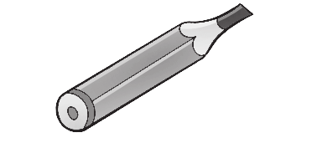
4. Is this your ?



5. Is this your ?

5. Write. This is These are


- These are my eyes

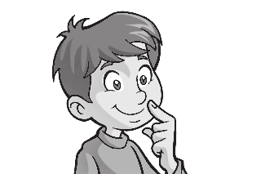
- _________ my nose
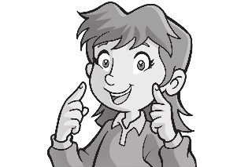

3. _________ my face


4. _________ my hands

